My Experiences in Samara
It was a warm, autumn morning after a 14 hour long train ride from Novomoskovsk, when I first set foot on the land of Samara. I shared this moment with two of my good friends; my country-mate Tsaone Gagonkgope and Fabrice Koumo Porgue from Chad, with whom I studied Russian language in Novomoskovsk. The first thing I saw, when I got off the train, were rows and rows of train tracks in the enclosed area of the railway station. We had to wait for one of my country-mates, Wachida and Oche from Nigeria who were kind enough to collect us from the railway station. I remember that I just couldn’t wait to see the outside. When they arrived, we went out to the main entrance of the station and I finally took in the air of the beautiful city. I found the tower of the railway station quite pretty. I liked the way its glass shimmered in the sun and that for a railway station it seemed quite tall.
My very first experience of Samara State Technical University was at the main building where I handed in my documents. It looked much better than it did when I liked it up on the internet, a beautiful, bright white, multi-storey building. I also find it quite interesting that it has the third and sixth building separately from the rest of the university. The university at home and in Novomoskovsk weren’t like that at all. Wachida and Oche came along with me to assist because I thought I would need certain difficult Russian terms explained to me. In the office for international students, I was very surprised to meet people who spoke very good English. They are all very kind and helpful. Each time I enter the room they are always happy to see me. After we got my documents sorted out, one young lady from the office at the time, Elena, kindly offered to drive us to my hostel in her own car, luggage and all!
I liked my hostel from the moment I saw it. It is a lot better than my previous hostel in Novomoskovsk. It may not be very spacious but it’s quite comfortable and a lot cleaner. On my floor there are care-takers. On the first day I arrived, one of the caretakers, did her best to help me feel at home. They have become like aunties to me and I believe to all the students on the floor.
My roommate, Roman, is a student in the faculty of journalism. He too was born quite far away from Samara in the city of Yuzhno-Sakhalinsk. I think he’s the best roommate I’ve ever had because he’s hardly ever around and so I have a lot of space to myself. Jokes aside, when he does come around he offers me treats from his home. One time he offered me some chocolate flavoured with sea salt! It was a strange but delicious treat. My neighbours (from the same block) are Aman, Alex, Eugene and Sergey. When we first met they were very welcoming. They even invited me for tea and biscuits in their room. I believe from then on we clicked. We’ve all become really close friends. It’s quite a shame that they will be graduating this year, but I hope to be seeing them often after that. It’s going to be difficult to say goodbye. I’ve also made friends with other students in the hostel
My first day of school at university was quite hectic. Firstly, I came significantly late to my first lecture. I remember it was a mathematics lecture. I came late because I still hadn’t known the directions to the 1st campus (building) from my hostel very well. I also found it confusing that the first, eighth and main building seemed to all be in one building. When I had finally found the auditorium, I entered to find what seemed like every first year student seated, staring at me. I expected the lecturer to make a scene and interrogate me about my late coming but, without pausing, she swiftly indicated that I should go and find a seat. It seemed as if every one’s eyes followed me as I went to take my seat, but I did my best to shrug-off the awkwardness and catch up with the lecture. I almost didn’t understand anything from lectures and lessons on that day. There were many moments were I would be aimlessly looking around while everyone would be writing and other moments of me being the only one trying to write what the lecturer was saying.
The preparatory course where I learnt Russian language was definitely much easier than freshman year. There was much more work to be done, more to study and a lot to get used to. The transition from studying Russian language to studying under the same conditions as Russian speaking students is very significant. I needed to spend a lot less time trying to look up and understand what words meant in order to get tasks done in time. I also had to listen a lot more carefully so I don’t miss out on important information like which assignments have been given and their deadlines.

In my country examinations are taken much differently than in Russia. For example, in Botswana, all examinations are in written form, students write their examinations seated in halls under tight supervision of the examiner. Once the examination is over the papers are taken to be marked and the students’ results are posted on notice boards, arranged by student number. These were the kind of examinations I was expecting when I came to Russia. The grading system is also quite different. In our country marks are calculated in percentage form. Marks can also be marked on a scale from A to F, A+ being the highest mark and F the lowest. For a student to pass an exam he/she must have a grade no lower than a C-. It took me some time but in the end I got used to these changes
Another issue I had to get used to was getting on a bus or tramway to get to the university. I got lost in the city countless times in the first few weeks due to taking the wrong bus getting off at the wrong stop. One time I dropped off at the wrong stop not too far from the sixth building of the university so I used the navigation on my phone to find my way. As I was walking I met a three high school children who offered to help me find Vilonovskaya Street. They had never met anyone from Africa before, as we walked they asked me a lot of questions about where I lived, how my country looks, how I came here, my family, what I do for fun and more. It felt uncomfortable giving off so much information to people I had just met but I did my best to answer wisely. The least I could do was talk to them because they were helping me. They turned out to be quite friendly and we shared contacts on Vkontakte.
The relationship with my group-mates just like with my roommates has grown. I’ve made very good friends in the group and I am yet to make more. All my group-mates are intrigued and ask me questions about Africa and my country Botswana and how it’s like. I still do my best to answer all their questions. It would be nice if they could visit and tour the natural beauty of Botswana.
Every semester for three semesters, I attended English language conferences which I enjoyed very much. There is a wide variety of presentations by many bright students with a passion for learning and speaking English. It was also very interesting to listen to and learn from them, as well as from the special guests. In one of the conferences the special guest was a man from America. He made an interesting presentation about Education in America. In the last conference I attended the guest of honour was a Taiwanese lady who gave us an informative about the interesting aspects of the culture of Taiwan. These conferences were a great opportunity to talk about my country. I talked much about the education, engineering and about the culture of Botswana

In First Year, I was lucky enough to go on an excursion with some other students about religion and culture (sponsored by the university) around Samara. During this trip I had many first time experiences like visiting an Orthodox temple, a Jewish synagogue and a mosque. They were all very beautiful. I especially was in awe of all the paintings in the Orthodox temple, some of which were similar to the Catholic churches in Botswana. The mosque also had a very interesting structure. It had more rooms than I expected. Being in the Jewish synagogue was a totally new experience. There are so many different ornaments, rites and rituals I hadn’t heard of before. The view from the top of the Orthodox temple, it was simply picturesque. I even took pictures of it.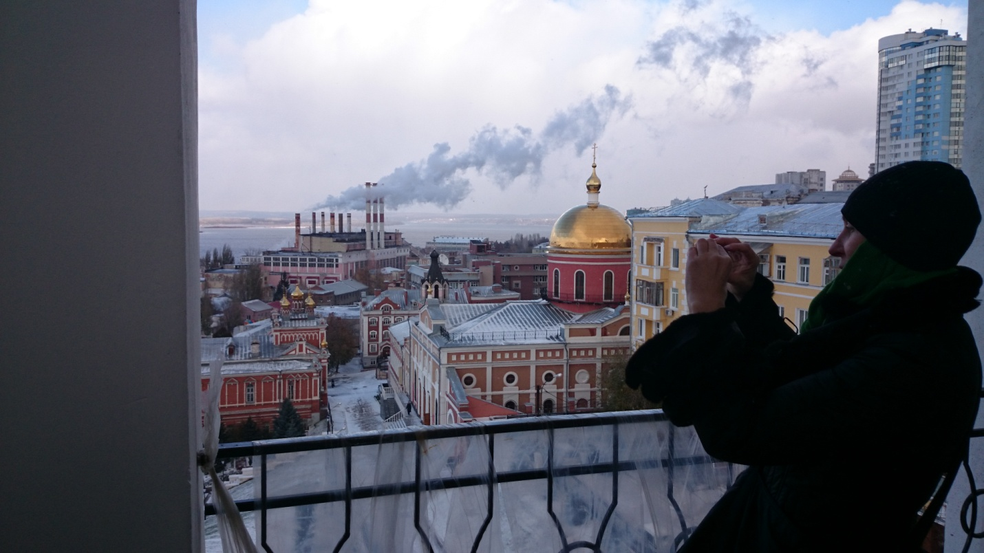

One of the greatest attractions in Samara is the Volga River. I remember learning about the Volga in geography class at school. It’s pretty amazing to actually see it live and have the opportunity to visit it regularly. Although Botswana is a land-locked country, we do have many smaller rivers and water bodies, the most famous being the Limpopo and Zambezi. Therefore I have seen something like the Volga before, however I’d never seen a river so massive. The first time I went to the Volga was with my friends towards the end of freshman year. I have also had the opportunity at the end of the fourth semester to take a ferry ride on the Volga with my friends. I was amazed by the beauty of the scenery. The ferry was filled with many tourists and locals young and old enjoying the beautiful summer sun and lovely scenery. When we got to the other side we set up a barbecue and played for some minutes on the beach. It was really fun and a good way to relax after the hectic last weeks of the semester.
Coming to SSTU wasn’t a personal choice. The dean of the Preparatory Faculty at Russian University of Chemical Technology filial at Novomoskovsk together with the Russian government made the decision dependent on my results and my faculty of choice. Before I came to Samara I really didn’t know what to expect. I hadn’t heard much about the city I didn’t even know which university I was going to. All I knew was that there were a few other students from Botswana in the city as well. I am glad that their hostels aren’t too far from mine so I constantly visit them.
One thing that really hit me by surprise was being the very first African student in the history of SSTU. I am very humbled to have been put on the faculty newspaper “Инженер” for the third time already. Before this, I had never been on any newspaper so it is a wonderfully surreal experience. When the papers got printed, I took one for my mom and my grandmother. The whole family was very excited about this. Upon understanding that I am the first African student and the only one in my university at that time in addition to having my dreams put on the faculty newspapers, I felt like there was a lot of attention drawn to me. I see this as an incentive to keep a good behavior and to do my best at school.
The one thing I may never get used to is rowdy behavior from certain people I may come across on the streets and sometimes in public transport. It’s unfortunate to bring it up but it honestly does happen more often than not. I’ve experienced minor situations like people staring at me for minutes on end without saying a word. Sometimes I’ve had youngsters try to sneakily take photos of me without my knowledge. I recall one funny situation in a crowded area where some girl ran in front of me took a quick ‘selfie’ and ran off. Some people have tried to ruffle my hair without even asking.
Despite all this, I’m grateful that these are all minor situations I can handle. I assume that the reason people do these things is because they rarely see someone from a different race who generally looks so different from them. I assume they probably believe they have to seize that moment while it lasts and so they say or do something rashly. I therefore make sure I do not react sharply and try to remain calm in the situation, which is what I’d advise new foreign students to do if ever they find themselves in such a situation.
Nevertheless it is not every passer-by who resorts to strange behavior. I have come across many strangers who politely admitted that they had never seen anyone like me before and so would like to feel the texture of my hair or take a picture or maybe ask a few questions. And only if they seem genuine I may comply with pleasure.
If you are planning to be a foreign student in SSTU my advice to you would be to study very hard and use this opportunity to learn something new. Do your best to try to understand what is being taught and how it can help you in future. It is easier to be motivated to study and finish projects on time if you know why you are doing it.
As a foreign student who does not speak Russian language, learning in Russian and gaining the confidence to speak it can be challenging. However, it is best not look at the difficulty in learning the language as an obstacle but a chance to learn a new language which can open more doors for you where ever you go in future. Learning Russian language for me helped me realize that I actually love learning new languages. Being interested in a language can also make it easier to learn. From my perspective, someone from a different country and culture can say the same things you do only in a different language. Learning their language therefore can bring you closer.
Apart from language, there are many challenges in studying that a foreign student from very far away may experience. Many of these challenges may stem from a difference in education systems and the way examinations are taken. I urge new foreign students to try a bit harder and not lose hope if they do not perform as well as they do at home. Just keep trying even though it seems too hard. As Franklin D Roosevelt’s saying goes, ~When when you come to the end of a rope, tie knot and hold on!~
Many students who leave their homes for the first time to study in university may not be open about emotional adaptation to change. A simple change of environment can be stressful. Students who come from very far away to study may experience a culture shock. This can make students feel homesick and in some cases make them want to quit everything and come home. I too had to deal with this and it wasn’t easy. My advice would be to always remember why you’re travelled so far and think about how rare it is to find another opportunity to study abroad. I guarantee that once you’ve settled down and acquainted yourself to some people, these feelings will fade. If you can, and only if you can, save up some money and visit home for the summer holidays, with the knowledge of the foreign students’ office in the seventh building. And make sure you come back a few days before the next semester!
A student travelling to another country, away from family, may be faced with a fear of trusting someone they have just met. Being in a foreign country without family, however, does not mean he or she will be completely alone. Indeed one may have to fend for oneself a bit more and be a bit more vigilant and responsible; nevertheless it is more probable that you will build relationships with trustworthy people overtime. I would also encourage foreign students to not only make friends with people from their country but at least get acquainted to the locals as well. Leaning their language can help make you better acquainted and you’d be surprised at how much they’d like to learn your language. It would be a shame to miss out on knowing more about someone you will less likely meet in your home country, especially if you will be going back home after graduation. Who knows? You could may make good friends.
I may not have much of life experience I believe one should always dream big. In your mind you can never lose. Don’t limit your dreams because dreaming is free. It is a vision that God has given only you. You have got your entire life ahead of you to make your dreams a reality, no matter how old you are.
I am really happy to be studying in Samara State technical University. It is I wonderful experience I may even share with my grandchildren. I’m sure many other foreign students like me would want to experience this and so I urge them to enroll!

